HOME

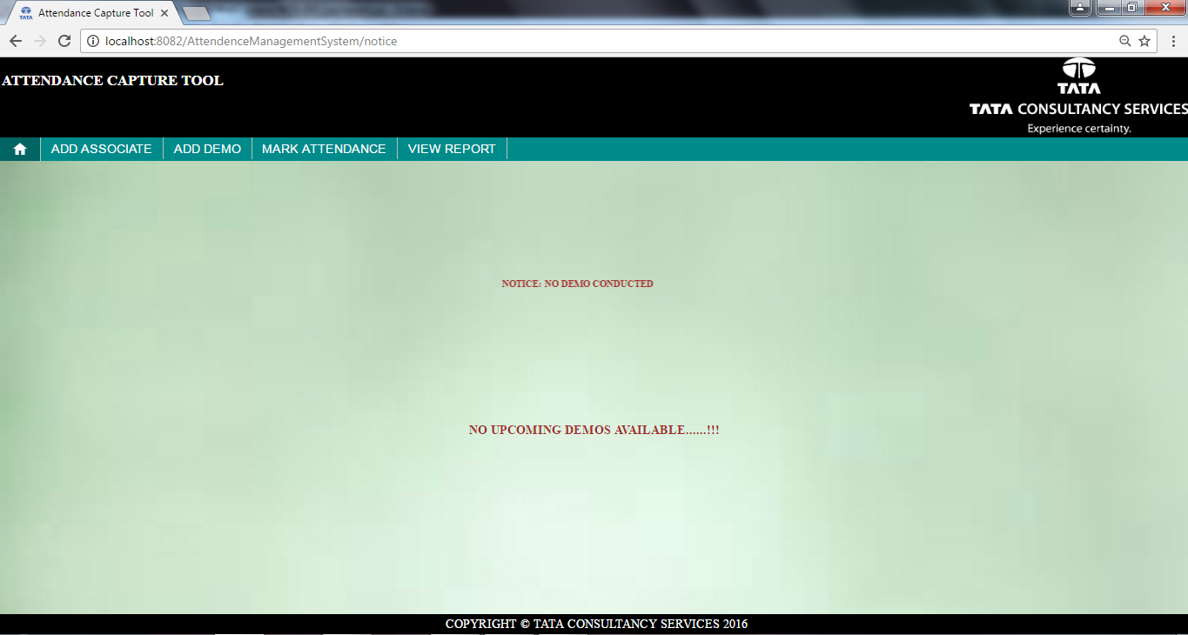

1:Click on Home tab, if no last demo and no upcoming demos, Home page looks like above.

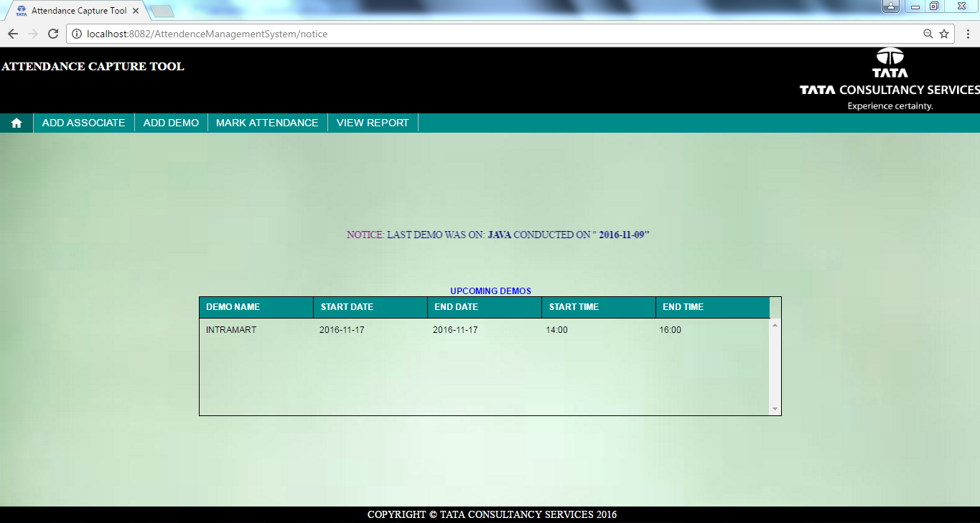
1:Click on Home tab, if demo is conducted and upcoming demo are present , Home page looks like
above.
ADD ASSOCIATE

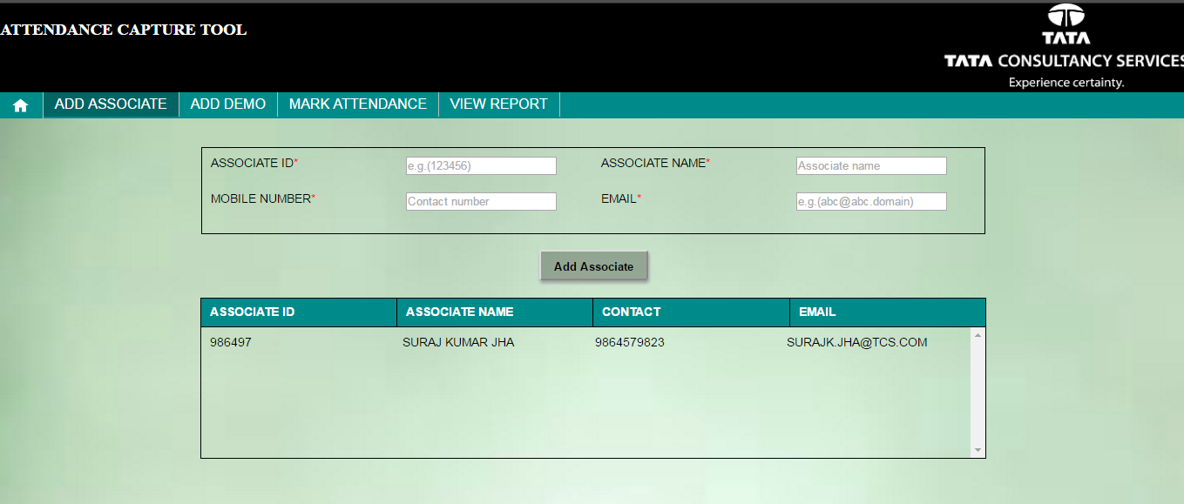

1.On clicking the Add Associate tab,the above page will be displayed.

2.The page will contain the details of associates showing in the associate table if any associate is
registered in the database.

3.In Associate Id textbox, we have to enter only numeric Id of 5 to 7 digits.(Example: 986497)

4.In Associate Name textbox, we have to enter the name of associate and can enter only
alphabets ranging from 4 to 30 characters(Example: Sohel Khan)

5.In Mobile number textbox, we have to enter the 10 digits mobile number,we can only enter
digits from 0-9.(Example: 7894561236).

6.In Email Id textbox, we have to enter the email id of associates.
We can enter alphanumerics as well as special characters in that field.(Example:
sohel.khan@tcs.com)

7.After clicking on the ADD ASSOCIATE button,the associate details will be saved in the
database and the table will be displayed alongwith “ASSOCIATE ADDED
SUCCESSFULLY” message.

ADD DEMO
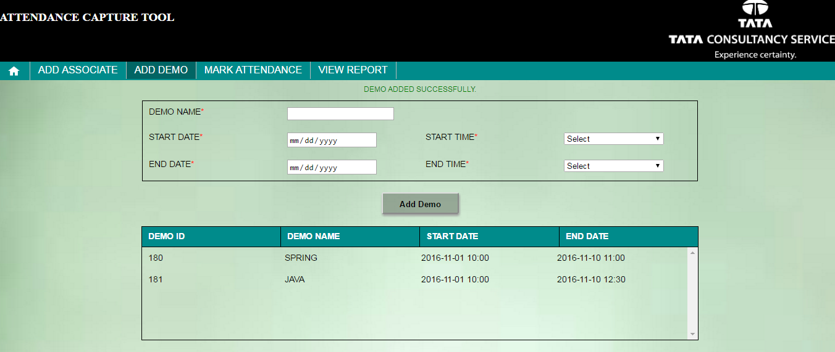

1.On clicking the Add Demo tab,the above page will be displayed.

2.The page will contain the details of demo with demo name and the demo dates if there is any entry of demo
stored in database.

3.In Demo Name,we have to enter the name in alphabets(for example: Java,Spring etc).

4.In Demo Start Date,we have to enter the date on which the demo is to be organised and
the demo date should be selected from the calendar being displayed.

5.In Start Time,we have to enter the timing at which the demo will be starting. We can select the start
time from the dropdown box.

6.In Demo End Date,we have to enter the date on which the demo will be completed,and
the demo date will be selected from the calendar being displayed.

7.In End Time, we have to select the timing at which the demo will get completed. We can select
the time from the dropdown box.

8.After filling all the details, when we click on the ADD DEMO button, the demo will be added in the
database and the table will be displayed with demo details alongwith the message
“DEMO ADDED SUCCESSFULLY”.

MARK ATTENDANCE
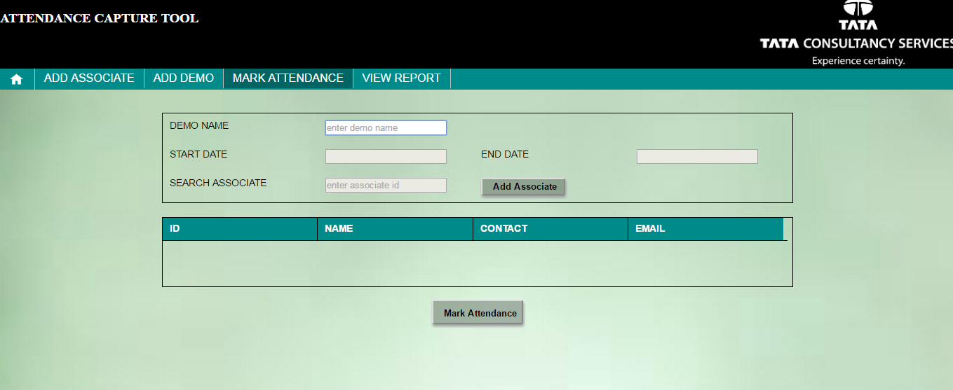

  - Click on MARK ATTENDANCE tab to mark the attendance of associates for the required
demo.
2. Enter demo name/starting alphabet and select the demo from the auto populated list only. Remember this auto populated list will only display the list of ongoing demos. If the demo does not exist in the auto populated list please go to ADD DEMO tab and add the required demo.

3. After selecting the demo from auto populated list START DATE and END DATE will display the demo start time and demo end demo time automatically. Remember this auto populated list will only show the list of ongoing demos.

4. Now enter associate id in SEARCH ASSOCIATE and select associate id from the auto populated list, if the associate id does not exist in the auto populated list please go to ADD ASSOCIATE tab and add the associate whose attendance is to be marked
.
5. Click on “Add Associate” button after selecting valid associate id,selected associates details will be displayed in the below table and add all the present associates for that demo.

6. Now click on “Mark Attendance” and attendance of all the chosen associates will be marked for the particular demo.

7. If you want to check the list of associates marked for the particular demo you can select the demo name from demo auto populated list and list of associates previously marked for that demo will be displayed automatically and there will be scope of marking attendance of remaining associates.

VIEW REPORT
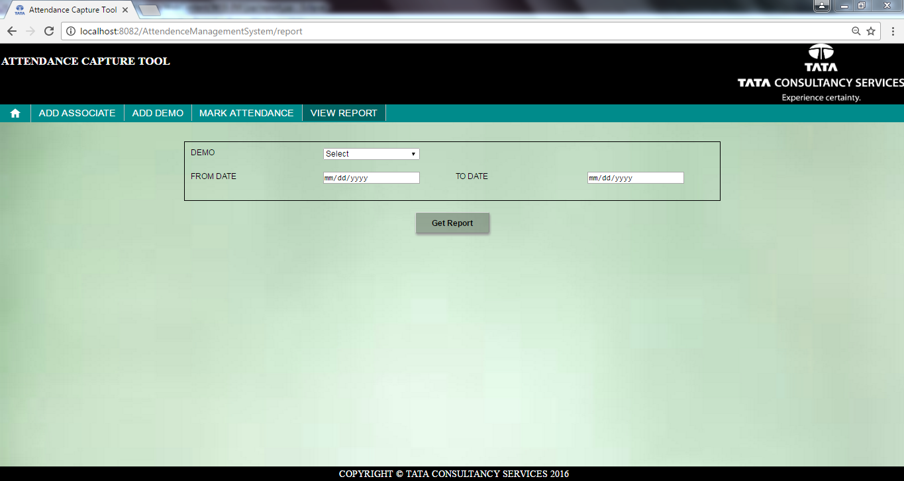

1.Click on VIEW REPORT tab, above page will be displayed.
2.To get the report, you can select only DEMO from drop down list or only FROM DATE and TO
DATE or DEMO, FROM DATE and TO DATE. According to your selection you will get the
report.
3.You can print report or can save as pdf.

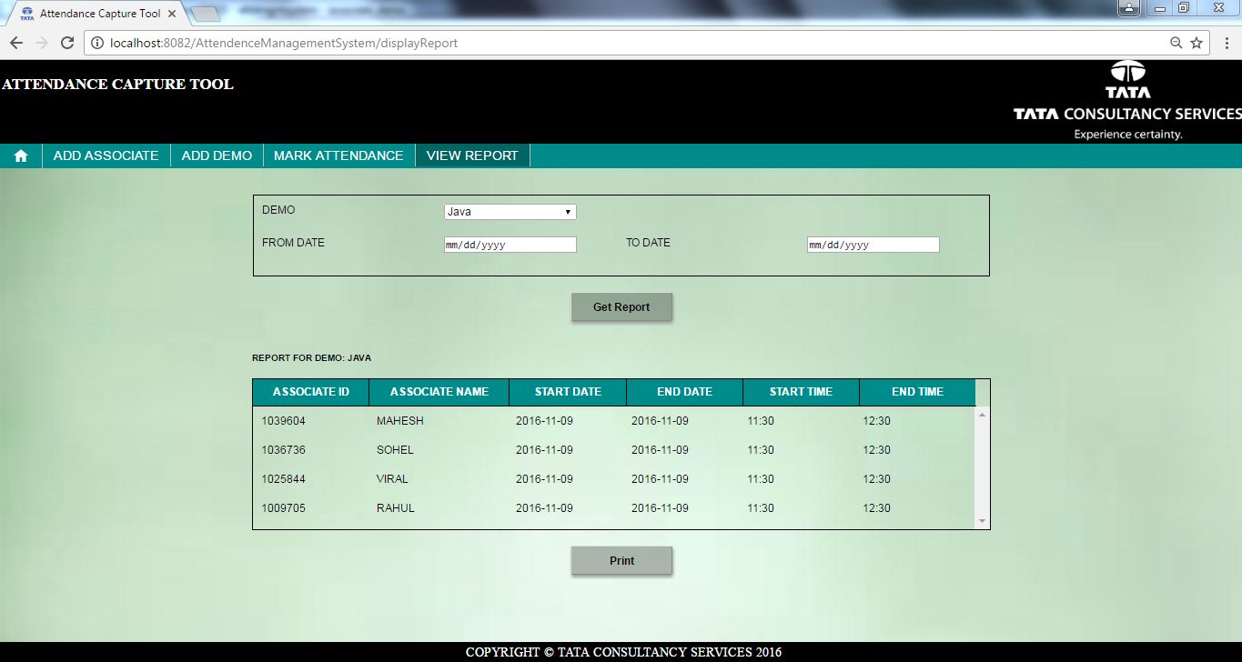

1:Select DEMO from drop down list(Example:Java)
2.click on Get Report, above page will be displayed.

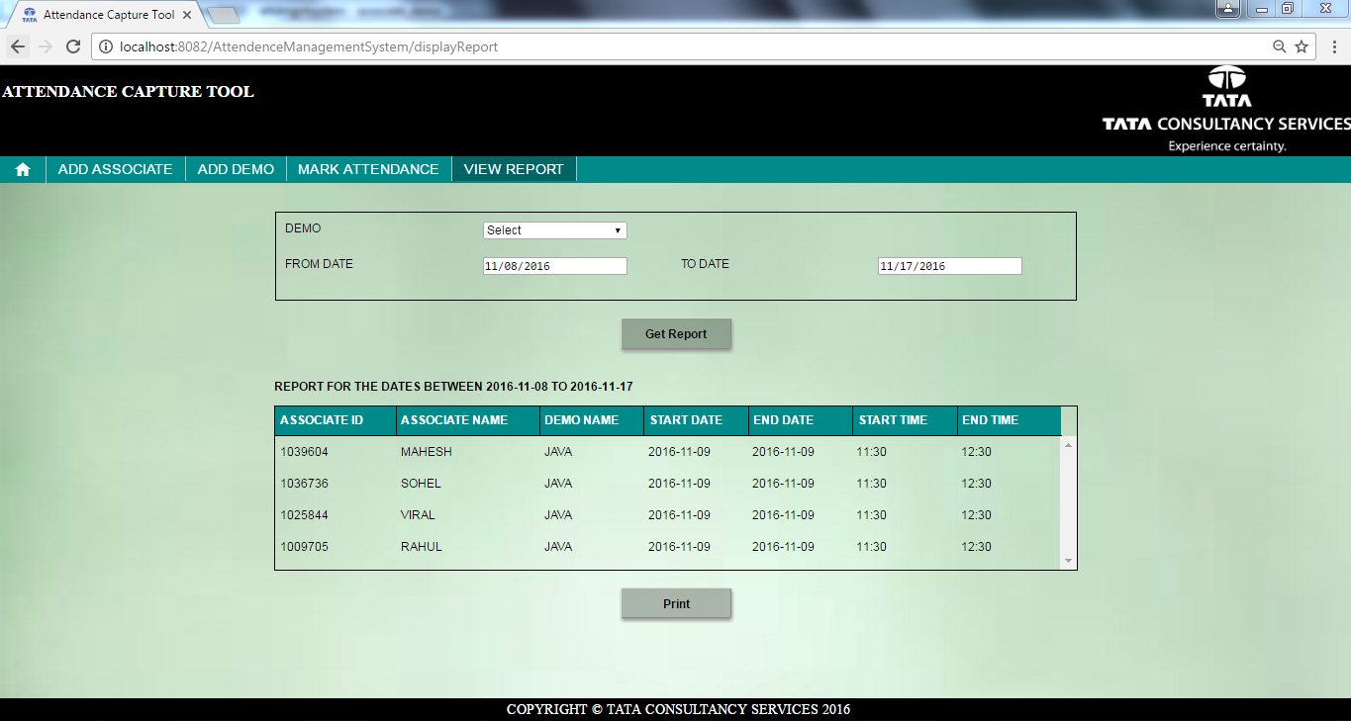

1:Select FROM DATE and TO DATE from calander.
2.click on Get Report, above page will be displayed.

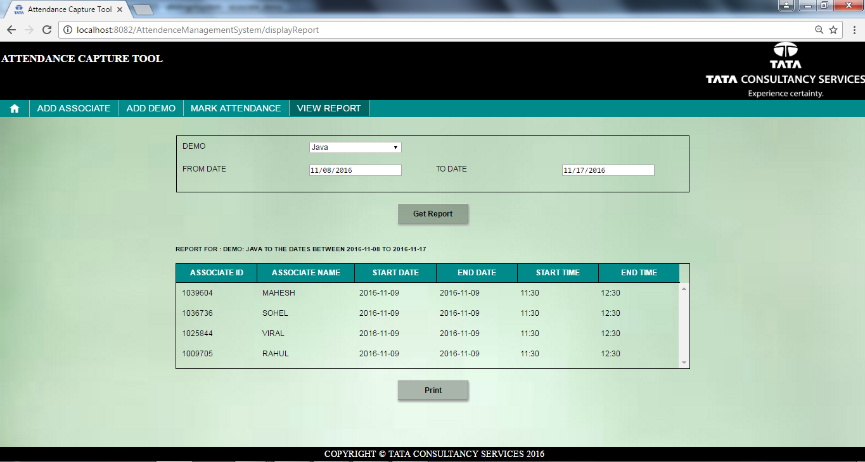

1:Select DEMO from drop down list,FROM DATE and TO DATE from calander.
2.click on Get Report, above page will be displayed.

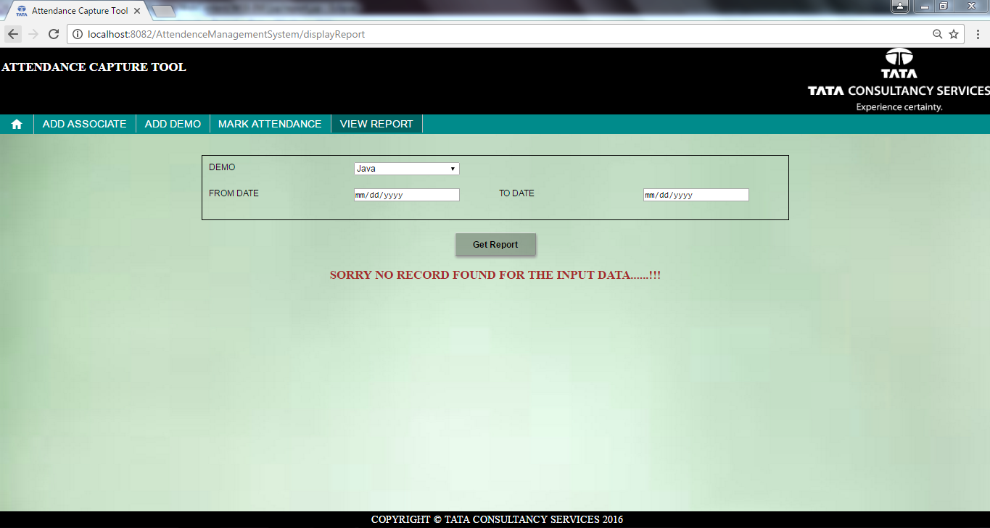

1.When no record present, above page will be displayed.

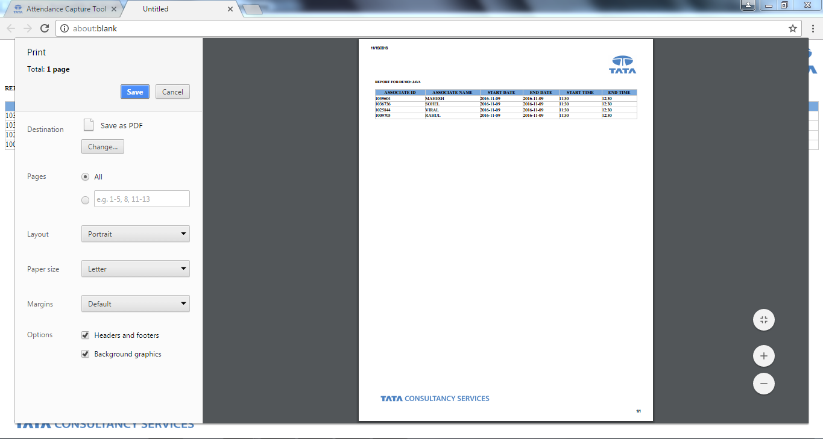
1.Click on Print, above page will be displayed and also you can save as pdf.

